**Team 6 Prototype Sprint 2**

By: Surafel Assefa, Steven Crowther, Gashaw Amalto, Kane Baldwin

Home Screen

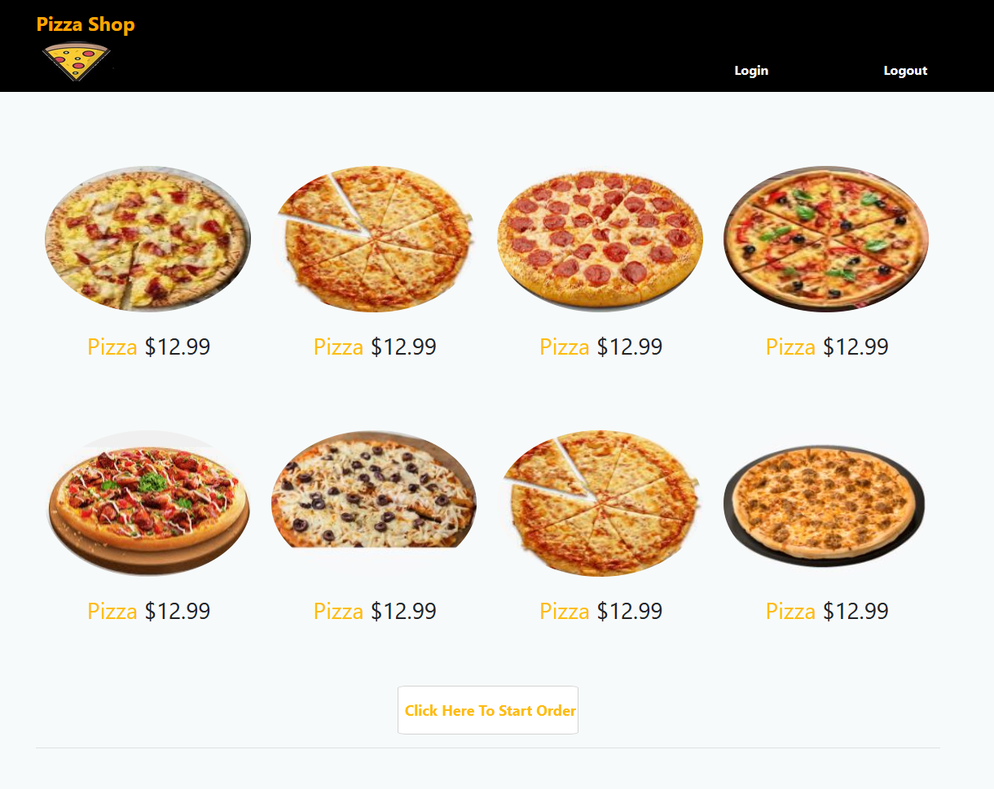

**Requirements:**

The home screen is used as the entrance to the website. Users should see this screen and be enticed into purchasing one of many delicious looking pizzas. Additionally, it’s required to lead directly into the login page or menu screen depending on whether the user is currently logged in.

**Use cases:**

* The user is hungry for a pizza, and finds Pizza Place as a good place to get one. Clicking the URL, they’re brought to a page with a list of pizzas and an “Place Order Now” button. The button is clicked, and the user orders a pizza through the rest of the website
* A user goes to the Pizza Place website to order a pizza for delivery. On the Home Screen, they see a pizza that catches their fancy, so they click it and are immediately brought to an ordering page with that pizza fully designed for them.

Login Screen

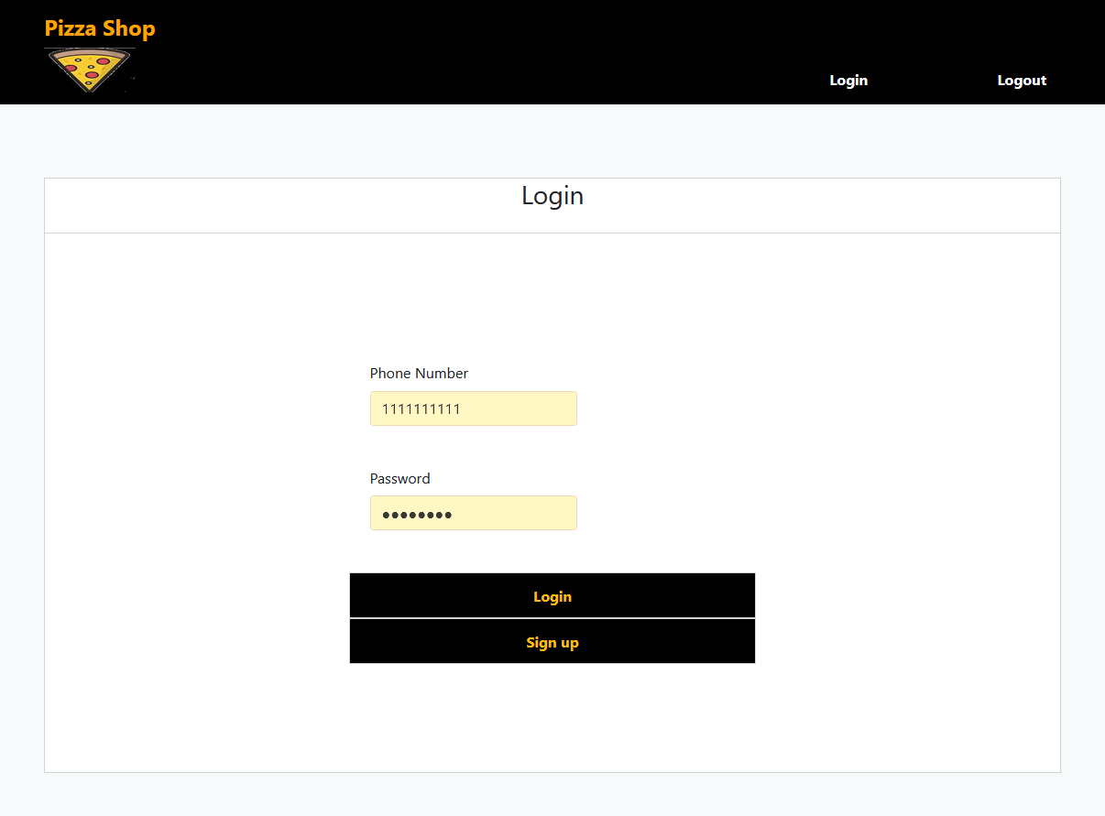

**Requirements:**

The Login Screen allows customers to access their accounts to request an order. Users will enter in the Phone Number and Password associated with their account and be brought back to the Menu Screen.

**Use cases:**

* A user goes through the Home Screen and is presented with the Login Screen. They’ve never ordered a pizza from Pizza Place before, so they don’t have an account and must make one. They click the “Sign Up” button and make an account. The user may then proceed to order a pizza.
* A user wants to order another pizza from Pizza Place and returns to the Login Screen. They already have an account, so they enter their previously selected username and password into the respective text input fields. They may then click the “Login” button to be brought to the menu screen and proceed to order their pizza.

Logout Screen

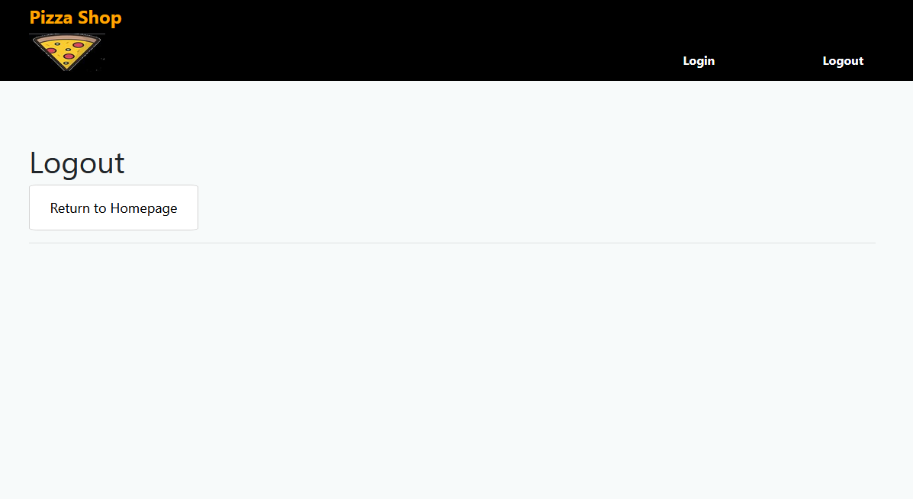

**Requirements:**

The logout screen must be displayed when a logged-in user clicks the “Logout” button in the top right of any page. When clicked, the user will no longer be logged in to the website and will have to re-login if they want to make additional orders. All session details such as the current order will be cleared.

**Use cases:**

* A user finished ordering their pizza and is finished with the website. They click the Logout button at the top right of their current page and are brought to the Logout Screen. They can now move on with their day knowing that the session is terminated.
* After the user has logged out, they also have the option to go to the homepage with the “Return to Homepage”.
* The logout link is available at any time for the user to click. Once clicked, all customer and order details will be removed from the session details.

Signup Screen

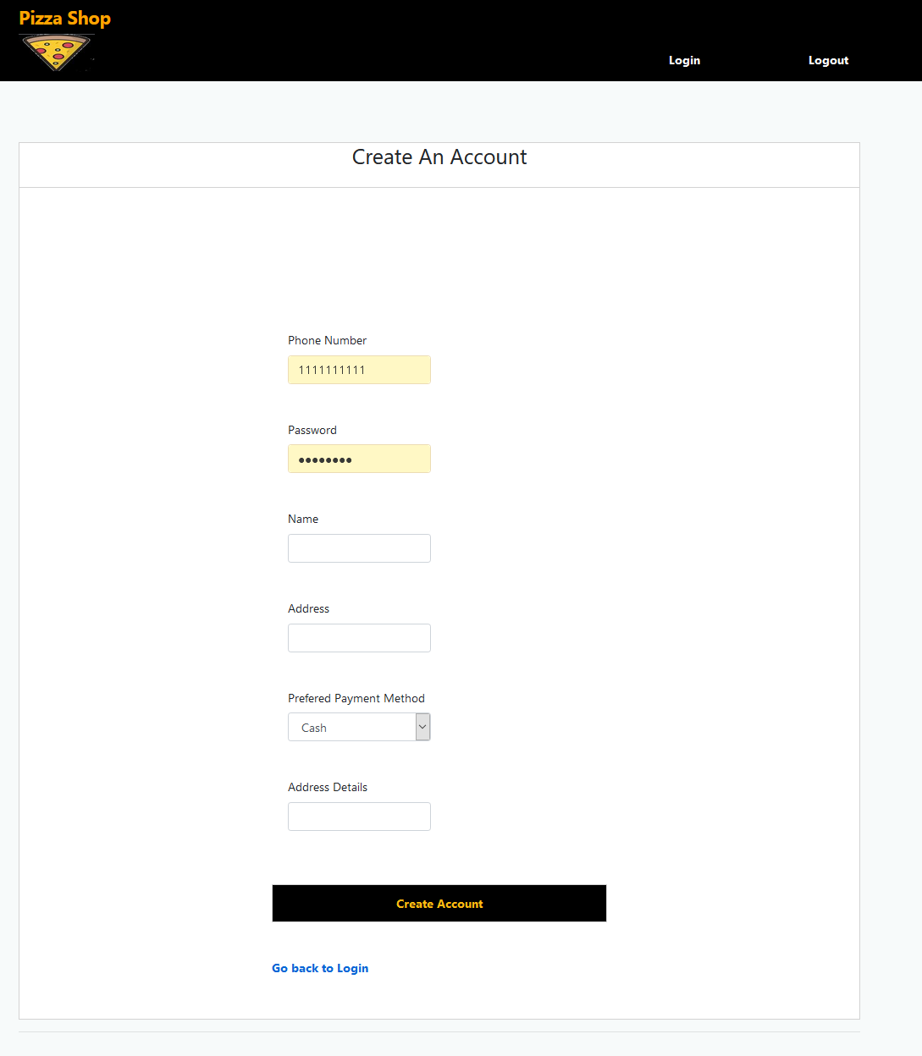

**Requirements:**

The signup screen must contain text input fields for a user’s Phone Number, Password, Name, Address, Preferred Payment Method, and Address Details. When all information is entered and the “Create Account” button is pushed, a new account will be created to represent it. However, if the Phone Number is already associated with an account the user will be warned “An account with this phone number already exists” and they must be refreshed to the Signup Screen.

**Use cases:**

* A user wants to order a pizza, but is first directed to the Signup Screen. They enter in their Phone Number(1234567890), Password(Pass12345), Name(Carl Johnson), Address(2264 Grove Street, Los Santos), Preferred Payment Method(Cash), and Address Details(Middle right house at end of culdesac). They are then returned to the Menu Screen where a pizza may now be ordered.
* If the user forgets they have an account, the page will reload with an error message saying that this phone number is already being used by another account.

Menu Screen

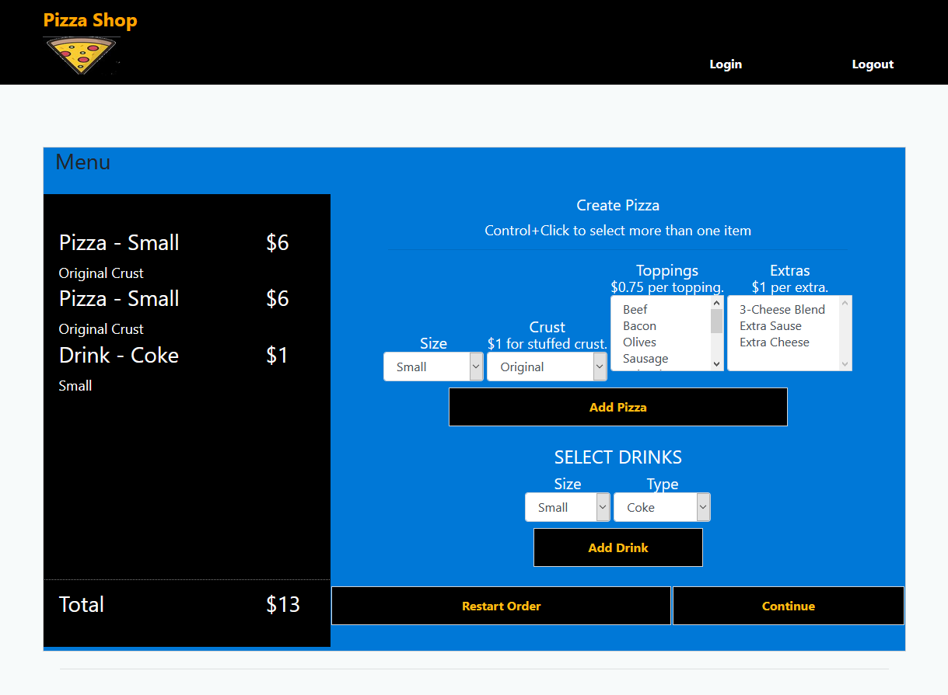

**Requirements:**

The user will have access to a series of dropdown menus allowing the creation of pizzas with any combination of Size, Crust, Toppings, and Extras. They will make the selections in the boxes, and click the “Add Pizza” button to add that pizza to the list on the left. There must also be 2 dropdown boxes allowing for the selection of drink Size and Type as well as a button “Add Drink” to move the selection to the box on the left. The “Restart Order” will remove all pizzas and drinks in the left box, and the “Continue” button will move the user to the Order Screen to confirm their order.

**Use cases:**

* The user desires a large thin crust cheese pizza and a large Pepsi. First, they select the size(large), crust(thin), toppings(none), and extras(extra sauce). To add order they must select the add pizza button. They may then select their drink size(large) and type(pepsi). They must then click the add drink button. Each time they press either the add pizza or add drink, the box on the left side is updated with the chosen item, along with the price for the item. On the bottom left hand corner, the user can see what the total price of their order is. If they are satisfied with their order, they can press the continue button.
* If the user has filled out all the options, but is not satisfied with their order, they have the option to press the restart order button.This will clear the list of items on the left hand side. At this point, the user will be able to fill out their preferred order.

Order Screen

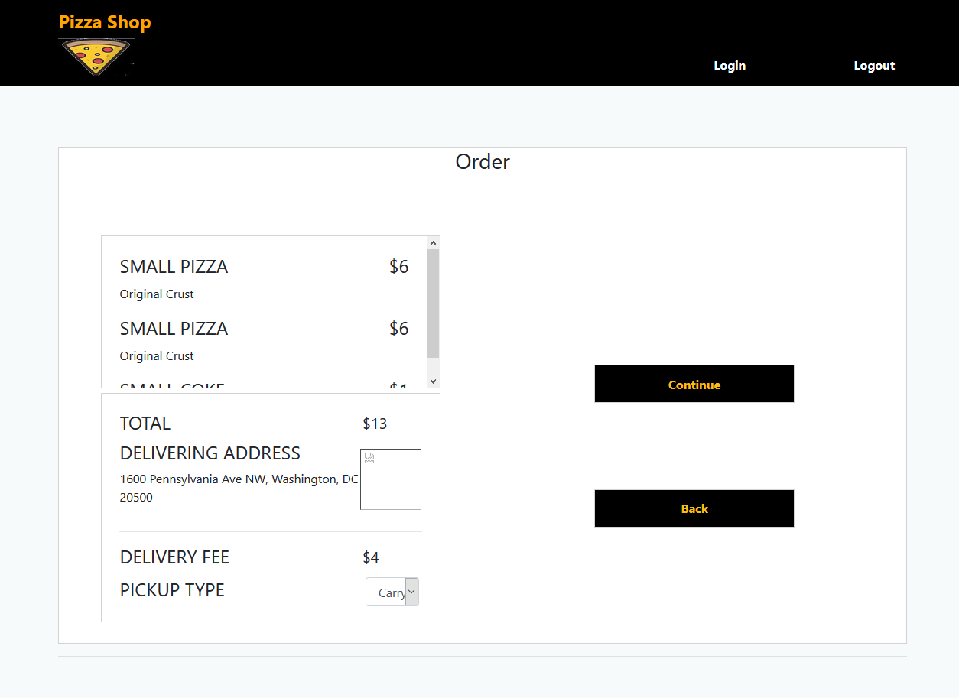

**Requirements:**

The Ordering Screen must contain all the pizza/drink information input on the Menu Screen along with their prices. The total price, delivering address, delivery fee, and selectable delivery method will be displayed as well. The pickup type will be changeable between Carry-out and Delivery which will change the delivery fee listed. The user will be able to either Continue on to the confirmation page or return Back to the Menu Screen to make adjustments to their order.

**Use case:**

* A user just finished their order on the Menu Screen, and was brought to the Order Screen. They see the pizza and drink they ordered listed on the left confirming their order. Below that, the user confirms the address to which the pizza will be delivered accessed from their account information. The user wants to drive to pick up the pizza, so they select “Pick Up” from the PICKUP TYPE dropdown box. Finally, they click the Continue button to confirm their purchase.
* After putting in their pizzas, a user comes upon the Order Screen. However, they failed to factor in the delivery cost and can no longer afford the order. They click the “Back” button to go make their order cheaper before returning and confirming their new order with the “Continue” button.